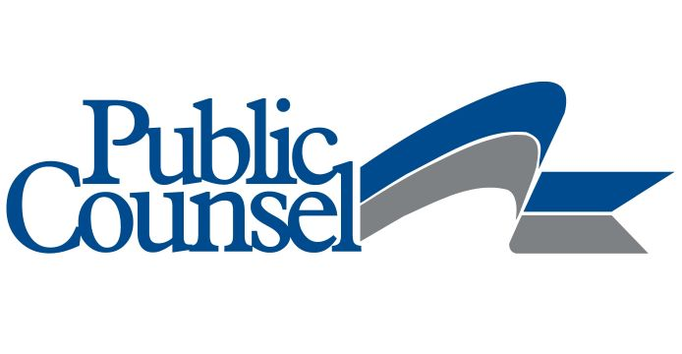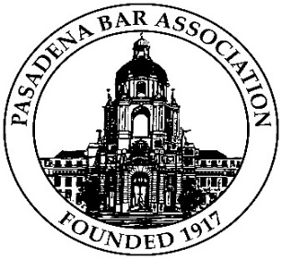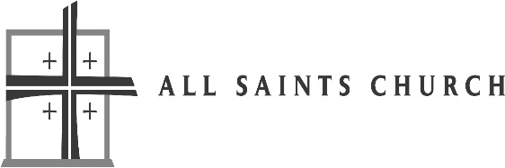
FREE LEGAL CLINIC!!
THE SECOND SATURDAY CLINIC
AT THE JACKIE ROBINSON CENTER
WILL BE HELD THROUGH PHONE INTAKE

GET YOUR QUESTIONS ANSWERED DURING THE COVID-19 CRISIS:
RENTERS’ OR HOMEOWNERS’ RIGHTS
ACCESS TO CASH, FOOD OR HEALTH BENEFITS
UNEMPLOYMENT BENEFITS
IMMIGRANTS’ RIGHTS
QUESTIONS ABOUT A WILL OR TRUST
DIVORCE OR CHILD CUSTODY ISSUES
WHAT COURTS ARE DOING

GET YOUR QUESTIONS ANSWERED BY PHONE WITHOUT LEAVING YOUR HOME
Leave a message at this number:
(213) 637-3880
Receive a call back the second Saturday of the month between 9:00-12:00 (possibly before if attorneys are available)
Fill out this optional intake form: http://www.publiccounsel.org/pages/?id=0106

